LOSS, SADNESS & GRIEF

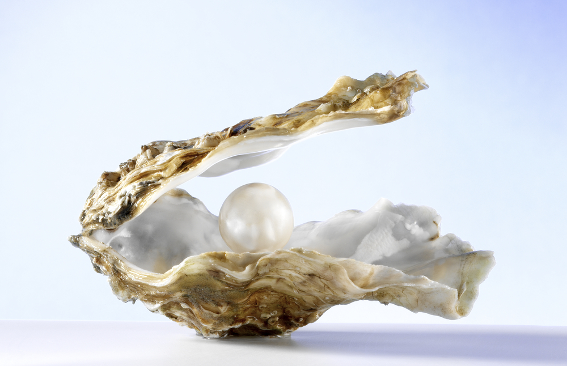

BY LOOKING DEEPLY INTO GRIEF YOU MAY FIND LIFE CHANGING WISDOM

FIVE PRECIOUS GATHERINGS FOR WOMEN AFTER LOSS OF THEIR PARTNER *Margreeth van der Oord. Dates and information:* [*www.leven-in-aandacht.nl*](http://www.leven-in-aandacht.nl) *#0031 629566691.*

FOR EVERY WOMAN AFTER THE SECOND YEAR OF GRIEF

Based on awareness and (self-)compassion. A private interview will be scheduled before the start

Durf je tranen toe te laten

SESSION 1. UNWINDING THE TENSE BODY; INVITATION INTO RELAXATION

SESSION 2. EXAMINE THE BRAIN AND OPENING TO HAPPINESS

SESSION 3. EXPLORING BALANCE BETWEEN LONELINESS AND JOY

SESSION 4. REMEMBERING OUR TRUE NATURE & HEALING THE HEART

SESSION 5. SCULPTING “A HOUSE OF MEMORY” ; CLOSING BY HONORING YOUR PARTNER, YOURSELF AND YOUR RELATIONSHIP

Sessions will contain: guided meditation, silent periode, group activities. Small group max 12 persons**. Costs for guidance on Dana basis**. Sessions duration 2 ½ hrs. Location costs 4 gatherings and Sculpture costs (session 5) depending on the local situation see info!

NO EXPERIENCE WITH MEDITATION IS REQUIRED!