Qigong Grootmeester Teja Bell

2-day in Bosoord, Loenen (Gld,)

Friday 19th en Saturday 20th Januari 2018

Dana basis

#Integration #body #mind #well being # to the benefit of all

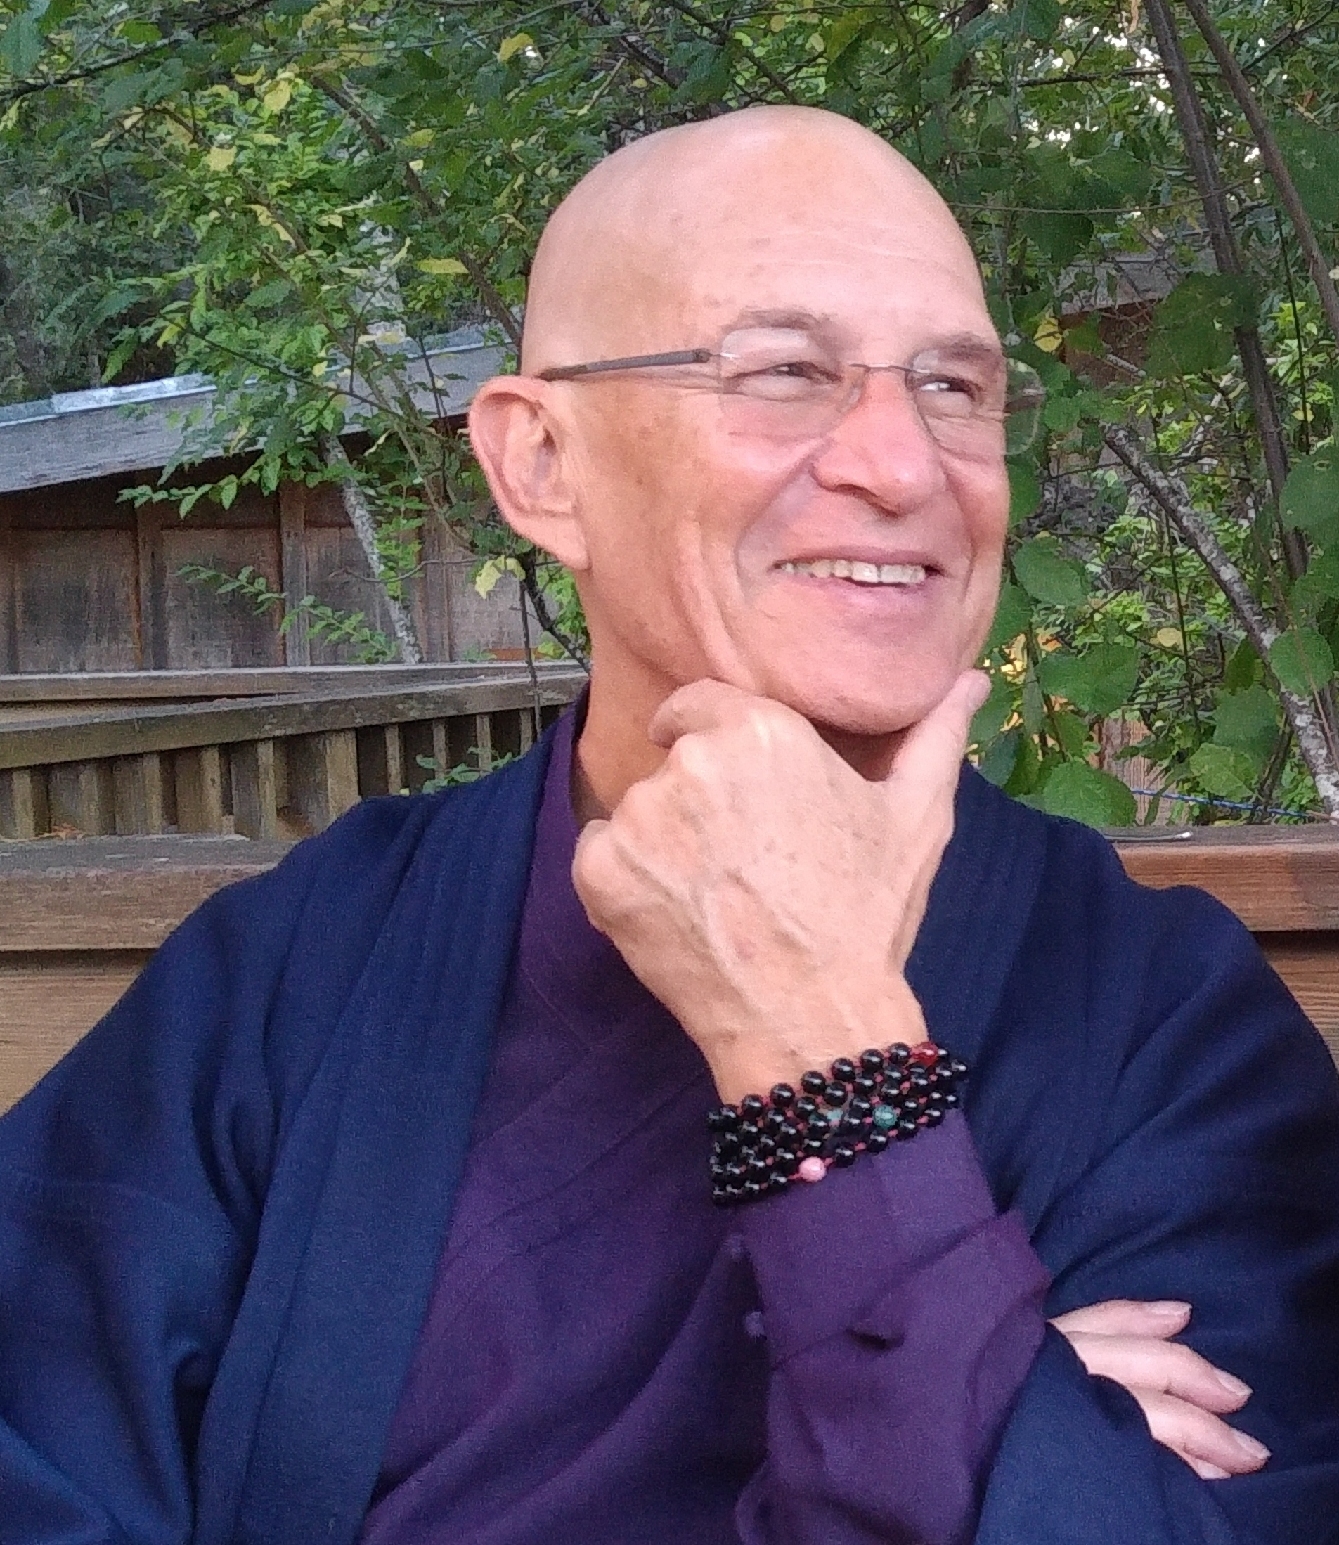

**Teacher Teja Bell**

With more than 40 years of experience training and teaching energy arts, healing practices and the dharma, Teja continues to integrate the practices of all wisdom traditions. He is an acknowledged master teacher of Qigong and Aikido and Chinese internal arts. He is also a fully ordained Rinzai Zen Priest and a musician. Teja is teaching around the world, he also is often teaching side by side with Jack Kornfield. Among many others, his holiness the Dalai Lama, Tara Brach and Jonathan Foust received his teachings as well. A Radiant Heart Teacher Training program is set up by Teja in the USA. For more information visit:[www.qigongdharma.com](http://www.qigongdharma.com)

**Radiant Heart Qigong** Radiant Heart Qigong empowers practitioners with calm, clear, vitality, strength and vibrant health. The teachings integrates contemplative practices with somatic learning as a gateway to the direct experience of being. It is easy to learn yet powerful in its transformational impact.  **PROGRAM** The 2-day will start on Friday. Signing in will be possible between 09.30 – 10.00 hrs. Lunch will be served at 13.00 hrs. The 2-day will end Saturday around 16.00 hrs.The retreat is in “Bosoord”, a Tibetan Buddhist center operated by the Maitreya Institute. The former hotel is located in a lovely area of forests and moorlands.

**FORMAT** To be able to embody this Radiant Heart Qigong practice fully there will be Qigong practice, meditation, breath intervals and space for Q&A. Teachings will be offered in English.

**ELIGIBILITY** The retreat is open to meditators and teachers of all wisdom traditions incl. yogateachers and mindfulnessteachers. The practice is accessible to every fitness level and conforms to individual need. If you have questions about the suitability of this retreat please contact Margreeth at: [margreethvdo@gmail.com](mailto:margreethvdo@gmail.com). Please specify your experience on the registration form.

**Registration**: You can download it from the site [www.simsara.nl/agenda](http://www.simsara.nl/agenda) in the column at the right side)

and send it to: Margreethvdo@gmail.com (for Dutch participants: in English please!)